**Machine Learning**

**ASSIGNMENT 1**

**Q1: a) Using NumPy create random vector of size 15 having only Integers in the range 1-20. 1. Reshape the array to 3 by 5 2. Print array shape. 3. Replace the max in each row by 0**

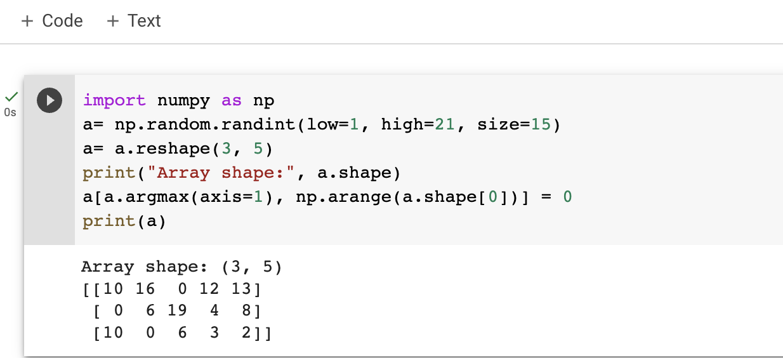

**Create a 2-dimensional array of size 4 x 3 (composed of 4-byte integer elements), also print the shape, type and data type of the array.**

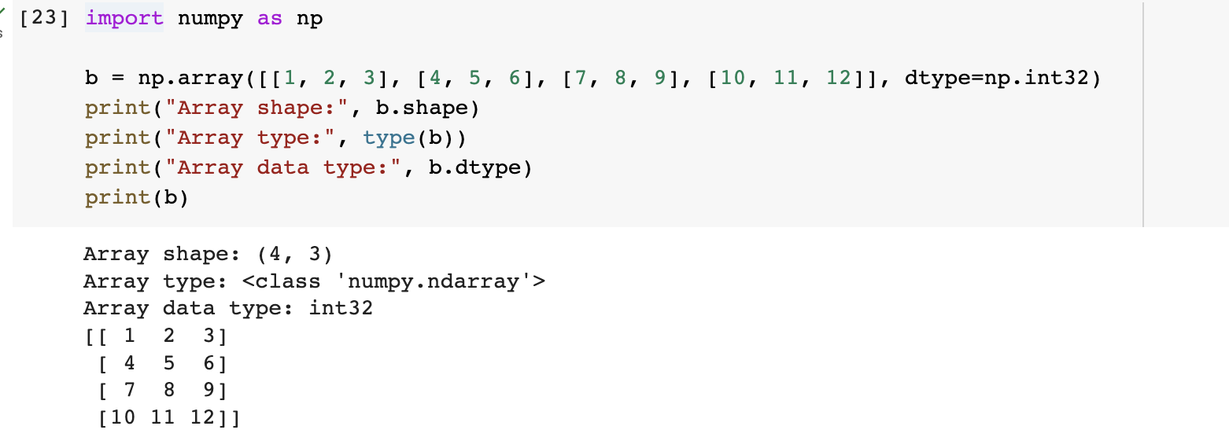

**b). Write a program to compute the eigenvalues and right eigenvectors of a given square array given below: [[ 3 -2] [ 1 0]]**

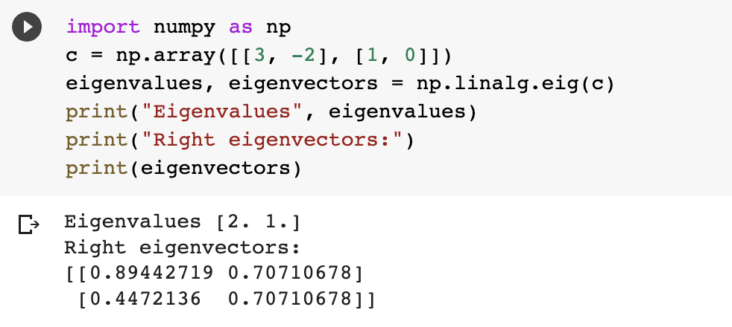

**c). Compute the sum of the diagonal element of a given array. [[0 1 2] [3 4 5]]**

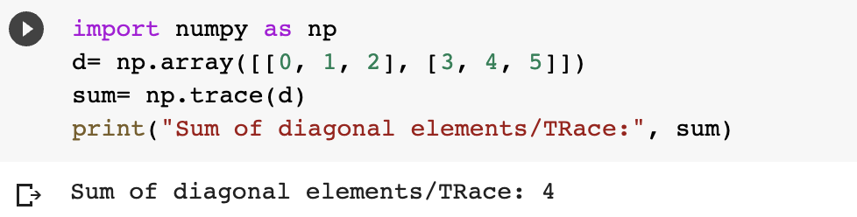

**d). Write a NumPy program to create a new shape to an array without changing its data.**

**Reshape 3x2: [[1 2] [3 4] [5 6]]**

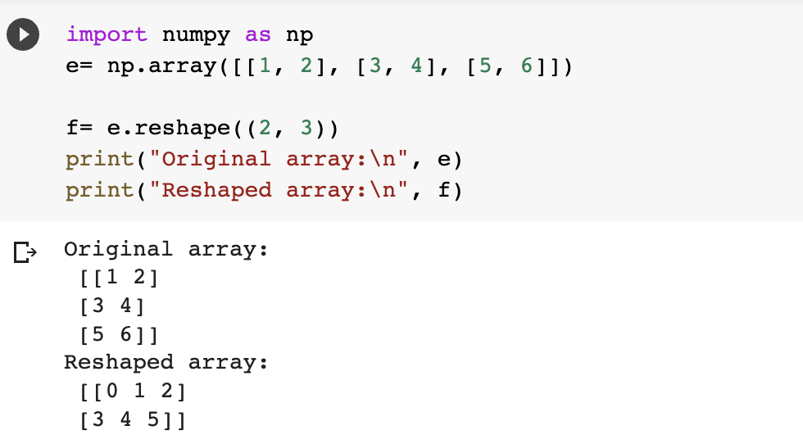

**Reshape 2x3: [[1 2 3] [4 5 6]]**

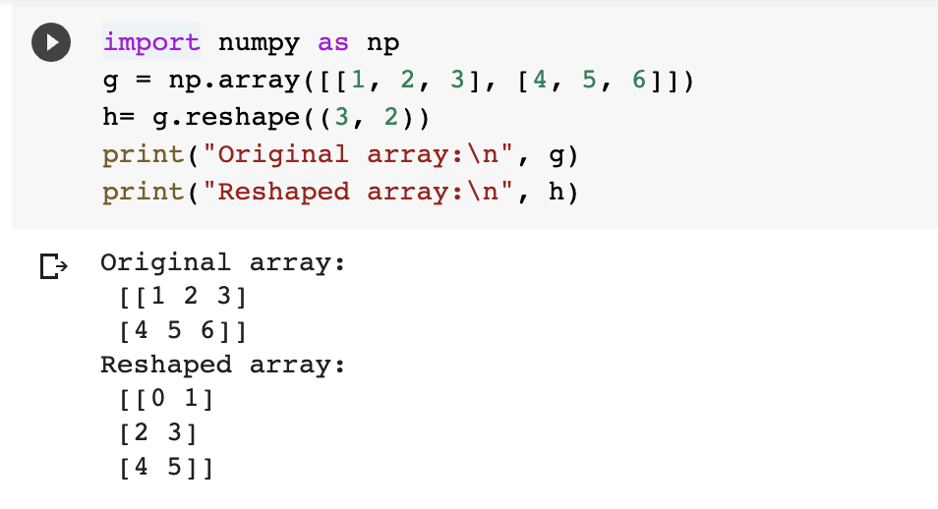

**2). Matplotlib**

**1. Write a Python programming to create a below chart of the popularity of programming Languages.**

**2. Sample data: Programming languages: Java, Python, PHP, JavaScript, C#, C++ Popularity: 22.2, 17.6, 8.8, 8, 7.7, 6.7**

